S E P T E M B E R 2 0 2 1 | V O L U M E 1 I I S S U E 1 I
GSA HIGHLIGHT
GSA LAUNCHES NEW WEBSITE!
The GSA is very excited to announce the launch of our new website: https://sites.rutgers.edu/gsa/
This will serve as the hub for all GSA event and meeting postings, documents, records, contacts, a new news/blog, and much more.

CONTACT US
Graduate Student Association
Rutgers Student Center Box 10
126 College Avenue New Brunswick, NJ 08901 https://sites.rutgers.edu/gsa/


GRADUATE STUDENT

ASSOCIATION
RUTGERS UNIVERSITY NEWSLETTER
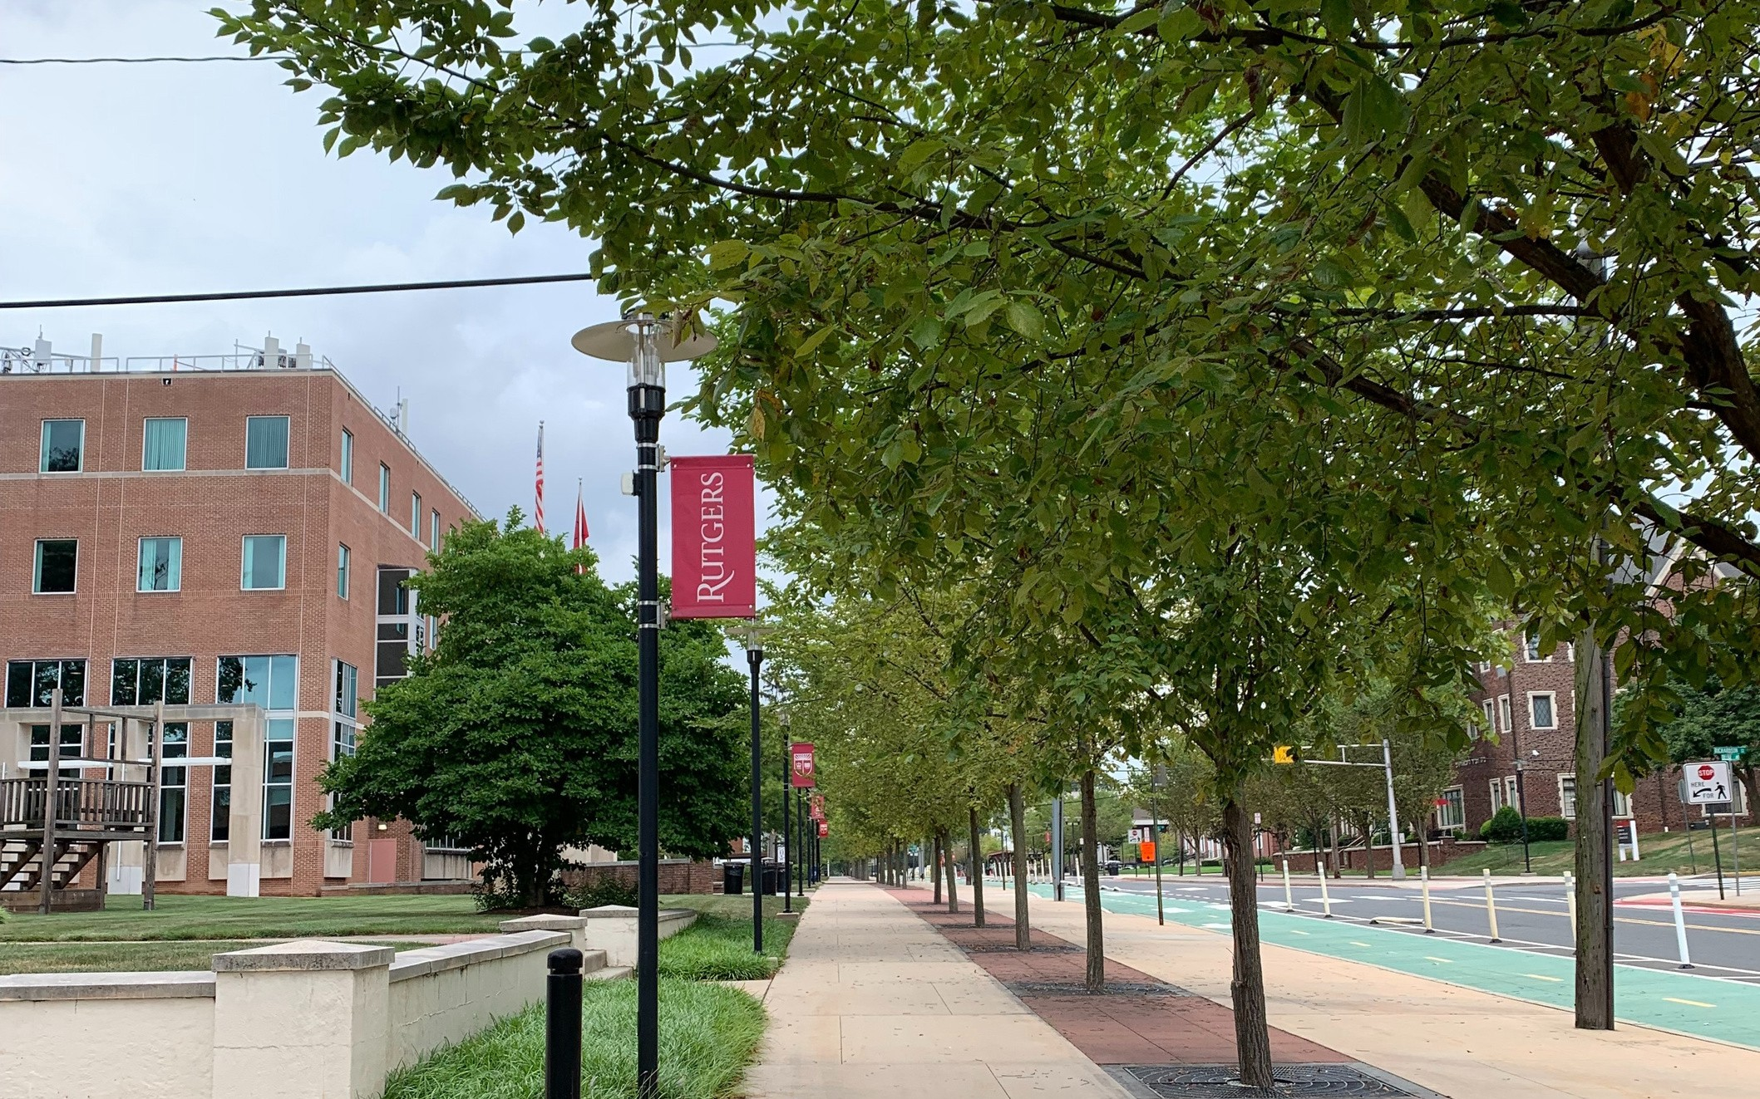
GSO REMINDERS
- Update your GSO contact info
- Register your GSO on GetInvolved
- Recognition and funding for the 21-22 AY requires maintaining an up-to-date profile on GetInvolved.
OTHER EVENTS
Zimmerli Opening Exhibition (9/1)
- http://zimmerli.rutgers.edu/art/exhibition/angela-davis-seize-time

- Angela Davis — Seize the Time

Back to School Meet and Greet (9/4)
- RSVP @ ru.graduate.chrisitian@gmail.com
- RUGCF will be hosting their annual meet & greet brunch from 10am to noon

GSA ANNOUNCEMENTS
- 2021-22 AY RECOGNITION AND FUNDING APPLICATION
Please visit the new GSA website, look for the "Graduate Organizations" tab and then "2021-2022 AY Recognition and Funding Application" in the dropdown menu.
- GSA SOCIAL: BACK 2 SCHOOL (9/10) @ 8 PM
As the new year begins, meet your new peers in a fun virtual world of Gather over dinner! Please REGISTER
- GSA COUNCIL MEETING: 9/13 @ 7 PM VIA ZOOM
Zoom details will be shared via Email to all GSOs
- GSA MENTAL HEALTH SURVEY
Please access the survey here: Graduate student mental health survey

*Please visit the new GSA website for more information: https://sites.rutgers.edu/gsa/



